Performance investigation and allocate appraisal index & compensation to employees fairly by using fuzzy-genetic inference system
(Case study: gachsaran oil & gas Production Company)

Chamran daneshdoost¹
1. PHD candidate in mechanical engineering (bio systems, renewable energies), National Iranian South Oil Company, chamrantmu@yahoo.com
Ali kordloo²
2. M.Sc. management, National Iranian South Oil Company

Abstract
In this paper, a fuzzy- genetic inference system is designed in order to analyze and investigate performance of employees of gachsaran oil & gas Production Company. About 30 employees were tested and the feedback of results from employees has been analyzed. The annual appraisal index and monthly compensation payment (overtime hours) that are important items for employees are discussed. In following an intelligent system based fuzzy- genetic algorithm designed in order to allocate annual appraisal index and monthly compensation to employees, properly and justly. Since employees satisfaction directly related to annual appraisal index and compensation, thus using a system that allocates them, probably and justly, is important. In this intelligent system that designed, the input factors are Discipline (entrance – exit), skill, experience, working conditions (temperature – distance from main office), hardworking and work load. And outputs are annual appraisal index and compensation. In this system optimization was done by using genetic algorithm.
This research was done in air conditioning & ventilation& refrigeration office (AVR) in gachsaran oil & gas Production Company. But, because of flexibility of fuzzy systems, the results of this research could develop to other offices of this company.
Key words: human resource management (HRM), fuzzy logic, genetic algorithm, annual appraisal index, monthly compensation

Introduction
A. Case study description:
Gachsaran oil & gas Production Company
This company is one of the major sub-companies of national Iranian south oil company, which produce 740000 barrels of oil per day. The main office of company located geographically in kohgiluyeh & boyerahmad province, but company established in the three province of Khuzestan, bushehr and kohgiluyeh & boyerahmad.
Air conditioning &Ventilation and Refrigeration (AVR) office
Engineering services office is one of the main sub-systems of Services management
Complex. And AVR is a sub system of engineering services office in gachsaran oil & gas Production Company. The management of equipment and human resources in this office is important and requires modern methods to evaluate performance and efficiency. Unfortunately traditional management methods in this office led to dissatisfaction of employees. Discussions, disputes and dissatisfaction of employees abut distribution of these indicators are challenge in this office, Thus design and implementation of an intelligent system to allocate appraisal index and compensation fairly, is necessary.
AVR Office units:
This office is made up of several sub-unites. The management unit is main part and leads the process and activities. Chart of sub systems and unites shown below:
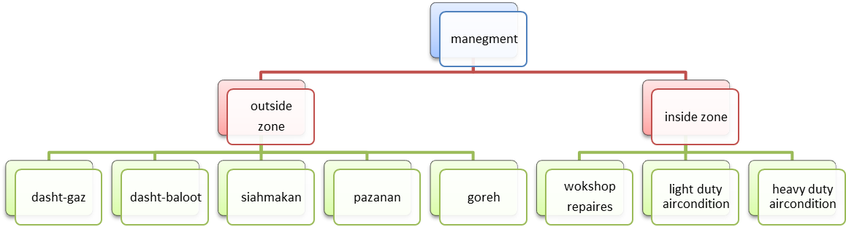

B. Research description
In this research which was conducted in gachsaran oil & gas Production Company, performance of employees has been investigated. And annual appraisal index and monthly compensation are allocated to employees by using fuzzy - genetic algorithm. The case study is Air conditioning &Ventilation and Refrigeration (AVR) office
in gachsaran oil & gas Production Company.
In the beginning we define basic meanings of human resource management (HRM) and intelligent systems. visually fuzzy and genetic algorithm.
Human resource management (HRM)
The role of human resource management is to plan, develop, and administer policies and programs designed to make expeditious use of an organization's human resources. It is that part of management which is concerned with the people at work and with their relationship within an enterprise.
The major functional areas in human resource management are: Planning, Staffing, Employee development and Employee maintenance.
These four areas and their related functions share the common objective of an adequate number of competent employees with the skills, abilities, knowledge, and experience needed for further organizational goals. Although each human resource function can be assigned to one of the four areas of personnel responsibility, some functions serve a variety of purposes.

For example, performance appraisal measures serve to stimulate and guide employee development as well as salary administration purposes. The compensation function facilitates retention of employees and also serves to attract potential employees to the organization.
Performance Appraisal
Performance Appraisals is the assessment of individual’s performance in a systematic way. It is a developmental tool used for all round development of the employee and the organization. The performance is measured against such factors as job knowledge, quality and quantity of output, initiative, leadership abilities, supervision, dependability, co-operation, judgment, versatility and health. Assessment should be confined to past as well as potential performance also. The second definition is more focused on behaviors as a part of assessment because behaviors do affect job results.
It is a systematic evaluation of an individual with respect to performance on the job and individual’s potential for development, in other word we can tell that, Formal System, Reasons and Measures of future performance.
It is formal, structured system of measuring, evaluating job related behaviors and outcomes to discover reasons of performance and how to perform effectively in future so that employee, organization and society all benefits.
Goals of Performance Appraisals are Developmental Use, Individual needs, Performance feedback, Transfers and Placements, Strengths and Development needs, Salary, Promotion, Organizational Maintenance and HR Planning Training Need.

Compensations
Compensations and recognition play an important part in motivating employees and improving performance. Compensation systems effectively control labor costs, improve employee productivity, and boost quality of services. A suitable designed compensation system can greatly enhance an organization's effectiveness and productivity. Nowadays, complex compensation systems are needed to meet the demands of a more diverse workforce.
These systems differ both within and between organizations. Increasingly, organizations are finding they must focus on the total compensation package for employees. Organizations are also developing more complex recognition programs which focus on non-monetary compensations for employees.

C. FUZZY LOGIC
The process of fuzzy logic is explained with this algorithm. Firstly, a crisp set of input data are gathered and converted to a fuzzy set using fuzzy linguistic variables, fuzzy linguistic terms and membership functions. This step is known as fuzzification. After wards, an inference is made based on a set of rules.

Lastly, the resulting fuzzy output is mapped to a crisp output using the membership functions, in the defuzzification step.

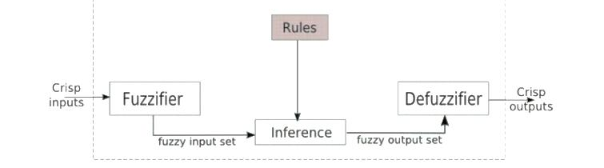
Figure1: a fuzzy logic system

Linguistic Variables:
Linguistic variables are the input or output variables of the system whose values are words or sentences from a natural language, instead of numerical values. A linguistic variable is generally decomposed into a set of linguistic terms.
Membership Functions:
Membership functions are used in the fuzzification and defuzzification steps of a FLS, to map the non-fuzzy input values to fuzzy linguistic terms and vice versa.
A membership function is used to quantify a linguistic term. Note that, an important characteristic of fuzzy logic is that a numerical value does not have to be fuzzified using only one membership function. In other words, a value can belong to multiple sets at the same time.
There are different forms of membership functions such as triangular, trapezoidal, piecewise linear, Gaussian, or singleton.
Fuzzy Rules
In a FIS, a rule base is constructed to control the output variable. A fuzzy rule is a simple IF-THEN rule with a condition and a conclusion.
IF statement1 IS.... AND statement2 IS.... THEN command1.
IF statement3 IS.... OR statement4 IS.... THEN command2.
The fuzzy base matrix represents fuzzy rules for a FLS. Row captions in the matrix contain the values that current statement can take, column captions contain the values for target command ,and each cell is the resulting command when the input variables take the values in that row and column.
Fuzzy Set Operations:
The evaluations of the fuzzy rules and the combination of the results of the individual rules are performed using fuzzy set operations. The operations on fuzzy sets are different than the operations on non-fuzzy sets. Let µ_{A} and µ_{B} are the membership functions for fuzzy sets A and B. Table1 contains possible fuzzy operations for OR and AND operators on these sets, comparatively. The mostly used operations for OR and AND operators are max and min, respectively. For complement (NOT) operation, issued for fuzzy sets.
Eq.1 µ'_{A}=1- µ_{A}

table1: Fuzzy set operation

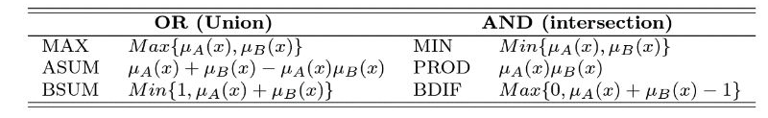
After evaluating the result of each rule, these results should be combined to obtain a final result. This process is called inference. The results of individual rules can be combined in different ways. The maximum algorithm is generally used for accumulation.

Defuzzification
After the inference step, the overall result is a fuzzy value. This result should be defuzzified to obtain a final crisp output. This is the purpose of the defuzzifier component of a FIS. Defuzzification is performed according to the membership function of the output variable. There are different algorithms for defuzzification too. The mostly used algorithms are listed inTable2.

Table2: Defuzzification algorithm

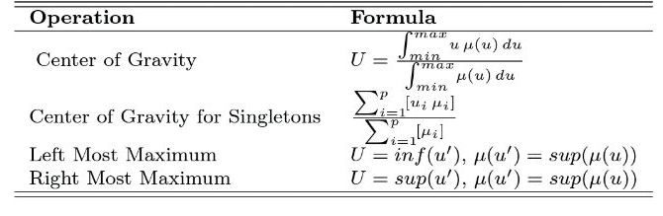

D. Design an intelligent fuzzy genetic inference system:
In this paper, an intelligent fuzzy-genetic inference system designed to allocate appraisal index and compensation to employees fairly. In this system used following inputs and outputs:
System's inputs:
Discipline (entrance – exit), skill, experience, working conditions (temperature – distance from main office), hardworking and work load System
Outputs: appraisal index - monthly compensation
Fuzzification of inputs and outputs is done by using triangular and trapezoidal functions. Designed main and subsystems system shown in figure2.

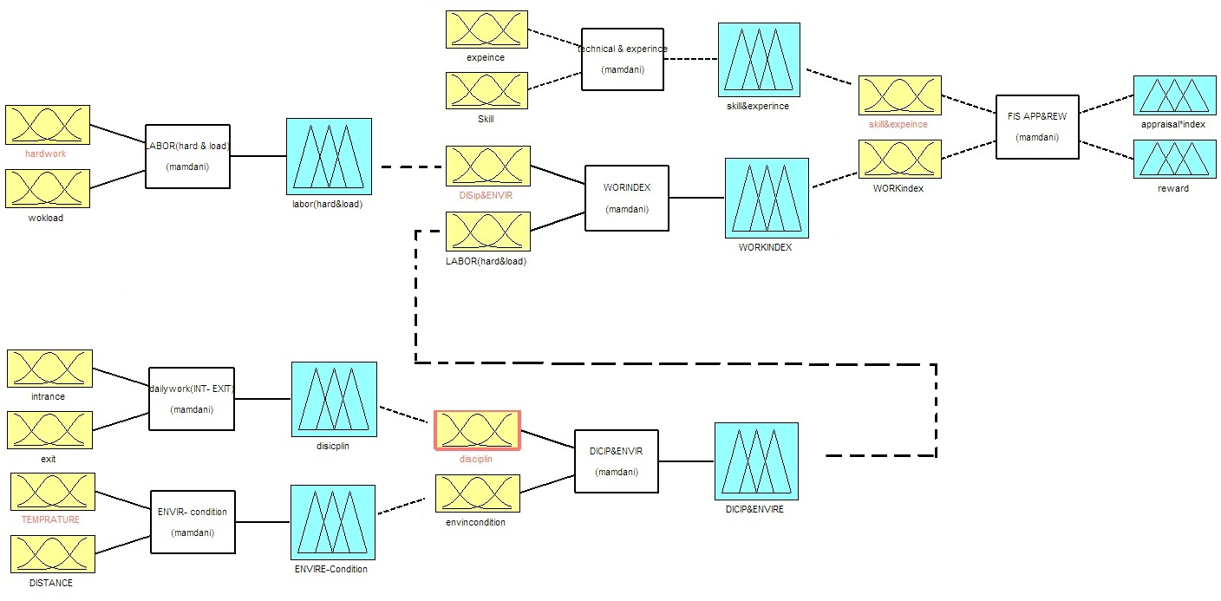
Figure2: fuzzy-genetic systems

Design main fuzzy system and Sub - fuzzy systems
1. Discipline (entrance – exit)
Inputs membership functions: entrance - exit
Outputs membership functions: discipline
Table3: rules base of discipline FIS
E | G | U | B | P | exit  entrance
G | U | B | P | P | P
U | U | U | B | B | B
G | U | U | U | B | U
E | G | G | U | B | G
E | E | G | B | B | E
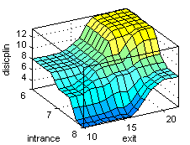

Figue3: output surface of discipline

2. Environment condition (temperature – distance)
Very far | far | mid | near | inside | distance  temperature
Z3 | Z2 | Z2 | Z1 | Z1 | cold
Z4 | Z3 | Z2 | Z1 | Z1 | moderate
Z5 | Z4 | Z3 | Z2 | Z1 | warm
Z5 | Z4 | Z3 | Z2 | Z2 | hot
Inputs membership functions: temperature, distance
Outputs membership functions: Environment condition
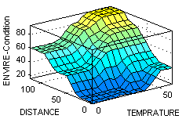
Table4: rules base of environment condition FIS
FIS

Figue4: output surface of environment condition

3. Technical & experience (skill – experience)
Inputs membership functions: skill, experience
Outputs membership functions: skill – experience index
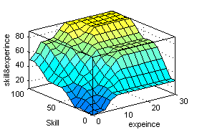
Table5: rules base of Technical & experience FIS

G5 | G4 | G3 | G2 | G1 | skill  experience
g5 | g5 | g5 | g5 | g1 | Poor
g4 | g3 | g2 | g2 | g5 | Bad
g4 | g4 | g3 | g2 | g2 | Usual
g5 | g4 | g4 | g3 | g2 | Good
g5 | g5 | g4 | g4 | g2 | Excellent

Figue5: output surface of Technical & experience

4. Labor (hardworking – work load)
L5 | L4 | L3 | L2 | L1 | workload  hard work
A | A | E | V.E | V.E | grade1
H | A | E | E | V.E | grade2
H | H | A | E | E | grade3
V.H | H | H | A | E | grade4
V.H | V.H | H | H | A | grade5
Inputs membership functions: hardworking-workload
Outputs membership functions: labor
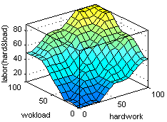
Table6: rules base of labor FIS

Figue6: output surface of labor

5. Environment condition & discipline:
Inputs membership functions: environment condition, discipline
Outputs membership functions: Environment condition & discipline index
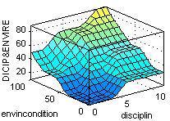
Table7: rules base of
Environment condition & discipline FIS

Z5 | Z4 | Z3 | Z2 | Z1 | Environment  discipline
g3 | g2 | g2 | g1 | g1 | poor
g4 | g3 | g2 | g2 | g1 | bad
g4 | g4 | g3 | g2 | g2 | usual
g4 | g4 | g3 | g3 | g2 | good
g5 | g4 | g3 | g3 | g2 | excellent

Figue7: output surface of Environment condition & discipline

6. Work index (discipline & environment condition - labor)
Inputs membership functions: discipline & environment condition - labor
Outputs membership functions: work index
Table8: rules base of work index FIS

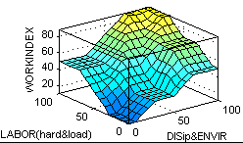
V.H | H | AV | E | V.E | labor  Dis&env
G3 | G3 | G2 | G1 | G1 | Grade1
G3 | G3 | G3 | G2 | G2 | Grade2
G4 | G4 | G3 | G2 | G2 | Grade3
G5 | G4 | G4 | G4 | G3 | Grade4
G5 | G5 | G4 | G4 | G3 | Grade5

Figue8: output surface of labor

Design main system (appraisal index & compensation) by using genetic – fuzzy algorithm
Input membership functions: skill & experience – work index
Output membership functions: appraisal, compensation
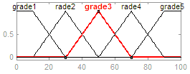
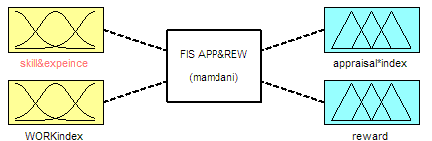

Figure10: input membership function
(Skill & experience)
Figure9: appraisal index & compensation FIS

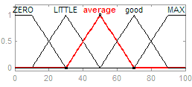
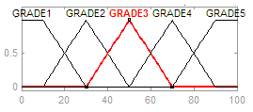

Figure11: input membership function (work index)

Figure12: 0utput membership function
(Monthly reward or overtime hours)

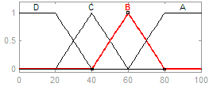

Figure13: 0utput membership function
(Appraisal index)

Fuzzy-genetic rules base
Matrix of fuzzy rules can be built using conditional rules. These conditional rules are logical expressions that are structured according to IF-THEN statements.
RULE1: IF ----- THEN ----- , RULE2: IF ----- THEN -----
By writing other rules, matrix of fuzzy rules be completed. This matrix has cells. By using genetic algorithm the optimal formation of matrix obtained.
Genetic algorithm (GA)
This algorithm is a free derivative stochastic optimization method. This method, generally, is based on the natural process of human life, which selects parents (selection operator), produce a child who inherits his parents genes (crossover operator), sudden changing in genes (mutation operator), and transferring some best genes from parents with no change to a child (elite operator). The important attribute of GA is its independence to GA’s flexibility facilitates both structure and parameter identification in complex models such as neural networks and fuzzy inference systems.
The procedure of the algorithm is explained in the following:
First, GA guesses randomly an initial population, which contains some chromosomes (depends on the specific problem). Each chromosome has some genes (equal to unknown parameters).
Second, GA employs each chromosome in objective function, so the first generation would be evaluated. Finally, to obtain the better second generation, it uses selection, crossover, mutation, and elite operators. This process is repeated for all generation to optimize the objective function as well as possible. The final generation contains the best chromosomes, which contains the best genes (parameters values). Generally, in this method used objective fitness function. Proportion of each person in the population is estimated. In this research, appraisal index and compensation are selected as the parameters of the objective fitness function. This process is done in five steps:
1. Initial population
According to inputs and outputs membership functions, 25 fuzzy rules used for compensation fuzzy system. Thus this fuzzy matrix filled with 5 ^25 Formations. And for appraisal system used 20 fuzzy rules and thus this fuzzy matrix filled with 5 ^20 Formations.
Each of these formations is called a chromosome and each rule or cell of matrix in its formation, is called a gene. For compensation matrix with 5 inputs and 5 outputs, 25 Cells, there are 5 ^25 chromosomes and each chromosome has 25 genes. For initial population 10 chromosomes and for each chromosome 25 genes are considered.
2. Fitness function
This is the most important part of the genetic algorithm, because directly affects the results. Four factors, appraisal index, compensation, expertise and work environment condition for this algorithm is intended. Thus five fuzzy symbols of membership function used below:
Working index: very hot condition – high distance –high discipline
Skill & experience: excellent skill - excellent experience
Since the efficiency and production are the most important goals of the organization, weight factor 1.5 for G5, g5 and weight factor 1 for g3, G3, Be considered. Thus the fitness function is obtained as follows:
F=1.5(G5+g5) + G3+g3
3. Survival and release
In this section there is a selective strategy. Proportion of chromosomes survives to be present in the next reproduction. Other proportions are released to be ensuring of reproduction result. This increases the efficiency of genetic algorithm. In this paper, the proportion of population that survives and proportion that released be considered 20 percent.
4. Reproduction
In this paper used 10 chromosomes in each reproduction. Two chromosomes with the least fitness are released and two chromosomes with most fitness are survived.
The others combine again to create six chromosomes. In other words, 2 chromosomes
that survived and six chromosomes that combined are main sections of reproduction step and two last chromosomes created from mutation step.
5. Mutation
The algorithm that used here is real genetic algorithm (RGA). In mutation step, two new chromosomes are created. These five steps lead to create new generation that is different from initial population. This process should be continued regularly until The minimum conditions of problem to be satisfied.
By using genetic algorithm the optimal formation of matrix obtained. Table9 shows the fuzzy-genetic rule base of appraisal fuzzy inference system (FIS). And table10 shows the fuzzy-genetic rule base of Compensation fuzzy inference system (FIS)
Table10: rules base compensation FIS

Table9: rules base of appraisal index FIS

G5 | G4 | G3 | G2 | G1 | Workindex  SK&EXP
A | A | L | Z | Z | grade1
G | A | L | L | Z | grade 2
G | A | A | L | Z | grade 3
M | G | A | L | L | grade 4
M | M | G | A | L | grade 5
G5 | G4 | G3 | G2 | G1 | Workindex  SK&EXP
C | C | C | D | D | grade1
B | B | C | C | C | grade 2
A | B | B | C | C | grade 3
A | A | B | C | C | grade 4
A | A | A | B | C | grade 5

Output results
Appraisal index and compensation are outputs of fuzzy-genetic system. Figure14 and Figure15 show the surface plot of appraisal index. Figure16 shows the surface plot of compensation output.
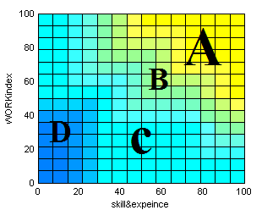
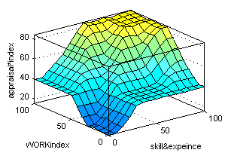

Figue14: output surface of appraisal index

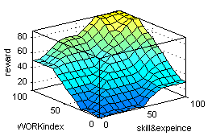
Figue15: distribution of appraisal index

Figue16: output surface of compensation

E. Results and conclusion
By using this intelligent system, about 30 employees were tested and the feedback of results from employees show that appraisal index allocated to them, according to the system distributed properly and fairly. Results using this intelligent and modern system compared to the traditional distribution system of appraisal and monthly compensation, show that the employees accept allocation of appraisal index fairly.
The results of this study with 7 fuzzy inference systems contain 6 subsystems and one main system show that implementation of fuzzy-Genetic algorithms that have been used for optimization, was successful. Genetic algorithm is used to optimize fuzzy relations and manager could apply considered weight factors to each entry of system.
In company, with conventional technique of management system, variables such as expertise, Work environment, hardworking and work load has been ignored. By applying fuzzy inference system, effects of these variables are shown clearly. The variables used in this system cause the allocation of appraisal index and monthly compensation distributed fairly.
Fuzzy inference system of discipline shows that by applying fuzzy system, the daily working of employees is estimated properly. Implement of fuzzy inference system for environment conditions shows that temperature and distance play an important role in the allocation of appraisal index and compensation.
By design and development of this system, the problem of equitable distribution of the annual appraisal index and the monthly remuneration of employees has been resolved.
Discussions, disputes and dissatisfaction of employees to distribute these indicators with regard to the transparency of this system are solved. Monthly remuneration (overtime hours) and the annual appraisal index is directly related to financial payment. Thus by using this system, the amount of overtime hours and annual appraisal index are moderate and the loss of financial resources for the poor and low performance of employees is prevented.

Acknowledgment:
Authors thank National Iranian oil company (NIOC) and National Iranian South oil company (Nisoc) for their help and financial support.

References

[1] Can Ouyang, Xiangmin (Helen) Liu & Zhengtang Zhang, 2016, "Organizational and regional influences on the adoption of high-involvement human resource systems in China: evidence from service establishments", the international journal of human resource management, Page 2058-2074
[2] Janet H. Marler & Emma Parry, 2015, "Human resource management, strategic involvement and e-HRM technology", the international journal of human resource management, Page 2233-2253
[3]. Danish.R & Usman.A, 2010," Impact of Reward and Recognition on Job Satisfaction and Motivation’’, International Journal of Business and Management, Vol 5
[4]. Zhou Jiang, Qian Xiao, Henan Qi & Lei Xiao, 2009," Total Reward Strategy: A Human Resources Management Strategy Going with the Trend of the Times", International Journal of Business and Management, Vol 4
[5]. Festing, M, & Sahakiants, I, 2011," Determinants of share-based compensation plans in Central and Eastern European public companies: An institutional analysis", Journal for East European Management Studies, 338-357
[6]. Khan dan Mufti, 2012, "Effect of Compensation on Motivating Employees in Public and Private Bank of Peshawar", Journal of Basic and Applied Scientific Research, 2(5) 4616-4623
[7]. Zaman, K.H.N.S.Shah,S.S. and Jamsheed.H , 2011," Relationship Between Rewards and Employees Motivation in Non-profit Organizations of Pakistan Business", Intelligence Journal, vol14
[8]. Gungor, Pinar, " The Relationship between Reward Management System and Employee Performance with the Mediating Role of Motivation: A Quantitative Study on Global Bank, 2011," Procedia Social and Behavioral Sciences, 1510-1520.
[9]. Boswell, W. R., & Boudreau, J. W, " Employee satisfaction with performance appraisals and appraisers: The role of perceived appraisal use, 2000," Human Resource Development Quarterly, 11(3), 283-299
[10]. Zhang-chun Tang, Zhen-zhou Lu, Ji-xiang Hu, 16 November 2014," An efficient approach for design optimization of structures involving fuzzy variables", Fuzzy Sets and Systems, Volume 255, Pages 52-73
[11]. M.S. Osman, Mahmoud A. Abo-Sinna, A.A. Mousa, 15 November 2005," A combined genetic algorithm-fuzzy logic controller (GA&FLC) in nonlinear programming", Applied Mathematics and Computation, Volume 170, Issue 2, , Pages 821-840
[12]. Peng-cheng Li, Guo-hua Chen, Li-cao Dai, Li Zhang, August 2012, "A fuzzy Bayesian network approach to improve the quantification of organizational influences in HRA frameworks", Safety Science, Volume 50, Issue 7, Pages 1569-1583

[13]. A. Mariajayaprakash, T. Senthilvelan, R. Gnanadass, May 2015, " Optimization of process parameters through fuzzy logic and genetic algorithm: A case study in a process industry", Applied Soft Computing, Volume 30, Pages 94-103
[14]. Fa-Chao Li, Li-Min Liu, Chen-Xia Jin, January 2009, "Study on fuzzy optimization methods based on quasi-linear fuzzy number and genetic algorithm", Computers & Mathematics with Applications, Volume 57, Issue 1, Pages 67-78
[15]. Emel lkaya Aydogan, Ismail Karaoglan, Panos M. Pardalos, February 2012, " hGA: Hybrid genetic algorithm in fuzzy rule-based classification systems for high-dimensional problems", Applied Soft Computing, Volume 12, Issue 2, Pages 800-806
[16]. F.J. Berlanga, A.J. Rivera, M.J. del Jesus, F. Herrera, 15 April 2010," GP-COACH: Genetic Programming-based learning of Compact and Accurate fuzzy rule-based classification systems for High-dimensional problems", Information Sciences, Volume 180, Issue 8, Pages 1183-1200

